

**FOR IMMEDIATE RELEASE** Contact: Prof D. I. Fotiadis – University of Ioannina

Phone: +30 – 26510 - 09006

Email: fotiadis@ uoi.gr

# HOLOBALANCE: HOLOgrams for personalised virtual coaching and motivation in an ageing population with BALANCE disorders

## Feasibility and effectiveness of the HOLOBALANCE telerehabilitation platform

**[Ioannina, Greece, Nov 2021]**

88% of participants in the HOLOBALANCE interventions achieved at least the minimal clinically significant difference in the Functional Gait Assessment (which is used to assess postural stability and an individual’s ability to perform multiple tasks while walking) scores vs. 55% for participants in the control group. Moreover, 82% of participants in the HOLOBALANCE interventions achieved at least the minimal clinically significant difference in Mini-BESTest (which is a standard balance measure) scores vs. 52% for participants in the control group.

Balance disorders are very common in older adults and have wide ranging detrimental physical, cognitive/psychological and life quality sequelae. Early detailed individualized assessment and treatment interventions for older adults with balance disorders at risk of falls is recommended by several guidelines but is often not implemented into clinical practice due to lack of resources and specialist knowledge.

The HOLOBALANCE platform (<https://holobalance.eu/> ) provides an advanced telerehabilitation solution that addresses the critical health needs of older adults with balance disorders. HOLOBALANCE features evidence-based exercises, cognitive and other gamified training, physical activity planning, and components that aim to improve motivation and compliance with the activities.

The proof-of-concept study, conducted from May 2019 to September 2021, with about 80 patients using HOLOBALANCE and 80 patients as controls, aimed to explore an advanced and more holistic approach to standard care. HOLOBALANCE is a tele-rehabilitation system which provides an individualised, prescribed program to be performed at home. The program has been originally designed by a specialist balance physiotherapist and is intended to be prescribed and regularly reviewed by a non-expert clinician. The system supports this by remotely monitoring task performance and providing the outcomes to the treating physiotherapist to review. The system comprises of a set of CE marked wearables (i.e., accelerometers, sensorized soles, smart bracelet), ambient sensors (motion capture sensor) and a head worn augmented reality display, which provide detailed movement and physiological data for the remote assessment of task performance (prescribed exercises, auditory tasks, and cognitive games).

The study **recruited 145** older **adults with falls/at risk of falls and middle aged or older individuals with a confirmed diagnosis of a vestibular disorder**. Participants were randomised into one of two intervention groups. One group received the HOLOBALANCE/HOLOBOX intervention, i.e. the home-based or the clinic-based intervention, and the other received the standard clinical treatment i.e., the OTAGO Home Exercise Program (HEP) for 8 weeks. All participants were required to undertake a daily exercise program intended to improve their balance, with the program overseen by a physiotherapist.

Despite the huge challenges since the study was performed during the COVID-19 global pandemic, recruitment and retention rates were good, dropout rates were low, and the estimated sample size was achieved. The COVID-19 global pandemic inevitably led to continuous recruitment and intervention uncertainty due to the various government restrictions imposed across the three study sites of Athens, Freiburg, and London and imposed challenges for participants, researchers, and treating therapists. We anticipate that these measures of feasibility would be better under less adverse circumstances. Importantly, the **absence of any adverse events** during the study related to participant interventions or associated with functioning of the HOLOBALANCE system suggest that **the program is safe to use in future studies and clinical applications.**

The high rate of exercise compliance (83%) observed across all study sites, and the improved balance perceived by 73% of these older adults, and those with vestibular disorders adds further support for the feasibility of the HOLOBALANCE programme implemented in this research. Furthermore, both the HOLOBOX and Home-based delivery of the systems appear to be **feasible interventions, regardless of the age, sex, or education level of this study population.**

Regarding effectiveness, for average baseline scores near normal or normal, 88% of all participants in the HOLOBALANCE interventions vs. 55% for participants in the control group improved their postural stability (measured with the Functional Gait Assessment scale - FGA). 82% of all participants in the HOLOBALANCE interventions vs. 52% for participants in the control group improved their balance (evaluated with the Mini-BESTest). Importantly, an average improvement of 25% for FGA and of 36% for Mini-BESTest for those with abnormal scores at baseline and eventually trained with HOLOBOX. It is anticipated that in a client group with greater disability and lower scores, the pre-post treatment change would have been even greater.

A high dosage (>50 hours) of challenging balance exercises has been associated with a successful reduction in fall rates in older adults. **Our findings though, indicate that a moderate dosage multisensory and multifactorial balance rehabilitation program may also have a significant effect on falls risk and intervention cost.** The potential benefit for these multiple factors is therefore immense and must be confirmed in a full randomised controlled trial.

An additional beneficial finding was noted for social well-being. In all groups a decrease, in the average total number of days during which their balance difficulties affected their ability to perform daily activities, was observed. Participants in the **HOLOBALANCE interventions combined, 87.5% achieved at least a 25% improvement in social wellbeing**. Moreover, a decrease of 14.66 days per month during which the participants’ balance impacted their lives in a negative way was demonstrated.

Further exciting findings were observed for **cognitive function scores with significant pre-post improvements (8%) noted for visual memory and new learning and visual pattern recognition memory.** It is well documented that falls risk is greater for those with cognitive impairment whereby all aspects of balance control deteriorate with increasing severity of cognitive impairment. This finding has significant implications for further studies in this area, particularly in individuals with cognitive impairment, and subsequently for clinical practice. Positive improvements in cognition, as those observed, may also contribute to the delay of onset for cognitive impairment and consequently prolong the active life of these older adults, with better quality of life, improved social wellbeing and reduced economic costs for their care.

The project involves 13 partners from across Europe and is coordinated by Prof. Dimitrios I. Fotiadis, who is Professor of Biomedical Engineering at the University of Ioannina.

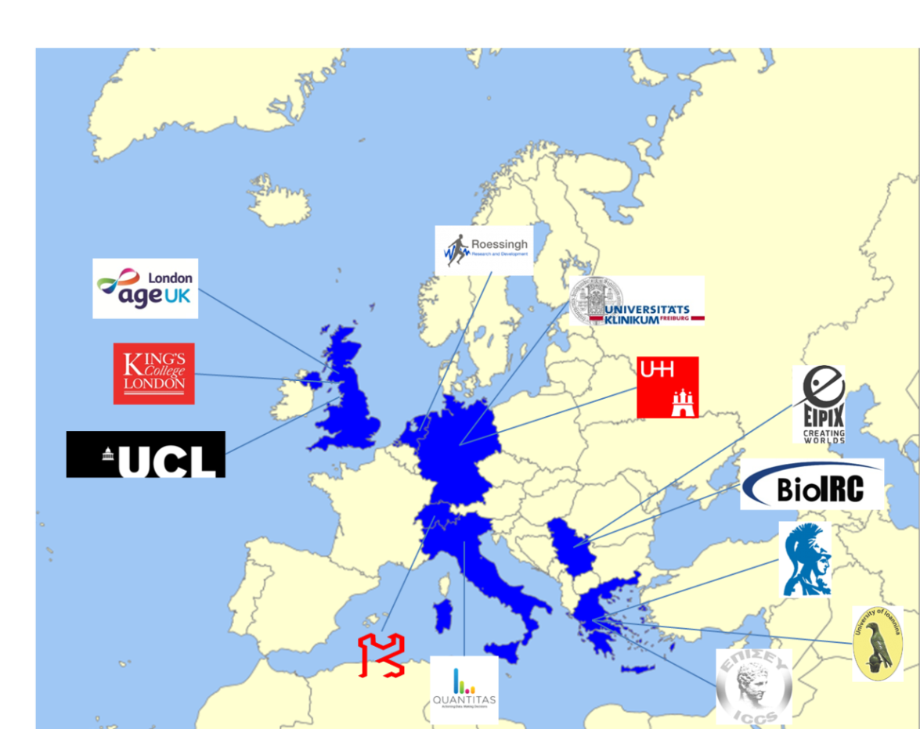

If you would like more information about the project visit <https://holobalance.eu/>

HOLOBALANCE has received funding from the European Union’s Horizon 2020 research and innovation programme under grant agreement No 769574.

